Orbyte GreenReady — Product Requirement Document
Orbyte GreenReady — From Bills to Better Business.
GreenReady removes one recurring task for Malaysian micro and small businesses: checking the monthly TNB bill and working out whether an energy upgrade is worth it. The owner forwards a bill in any format; the system checks every charge line, compares LED, inverter aircon and solar on the same formulas, and — only with the owner's approval — lists the business anonymously so green investors and suppliers can connect. Every company starts with RM10 of free credit, then pays RM2 per bill or RM29 a month as a member. Customers gain more than they pay from Year 1 (55% customer ROI), GreenReady breaks even in Year 2, and the 5-year plan facilitates 562 upgrades.
All figures are estimates for preparation only, not financial advice. Banks and suppliers make their own decisions.

1. Problem Statements
Every month a small business receives a TNB bill, but nobody has the time or know-how to check whether the cost is normal or which upgrade would cut it. Money for green upgrades exists; what is missing is simple, trusted evidence that connects SMEs with the investors and suppliers who could help.
Who is affected: 1.08 million micro and small enterprises in Malaysia (767,421 micro and 314,465 small, 2023) [1]. The most electricity-intensive groups — 59,316 manufacturing MSMEs [1] and 136,453 food & beverage establishments [2] — form our serviceable market of 195,769 firms. MSMEs produced 39.7% of Malaysia's GDP and 8.09 million jobs in 2025 [34].
Problem 1 — the recurring burden. Checking the bill by hand every month is slow, so most owners skip it and only notice a spike when cash runs short. SME owners already spend about 11 hours a week on admin and finance tasks (2026 survey) [3].
Problem 2 — upgrade decisions are made blind. Quotes come in different formats and from sellers who push their own product, so owners cannot tell which upgrade really pays back first.
Problem 3 — an evidence gap blocks funding and partners. SMEs cannot afford consultants to prove savings, so green financing and qualified suppliers stay out of reach, while banks and suppliers struggle to find ready SMEs.
Pain point | Evidence | Source
Electricity costs are rising | Energy-intensive SMEs reported up to 10% higher monthly bills; up to RM9,000 more a month in industrial zones | The Star via TNB, Aug 2025
No expertise to measure energy and carbon | A professional carbon audit or ISO certification costs RM20,000–50,000; SAMENTA names cost, expertise and confusion as the main barriers | The Vibes, Dec 2025
Data collection is the bottleneck | SMEs struggle with ESG data collection due to limited capacity and information overload | Business Today, Jan 2026
Missing energy data costs business | Some firms lost export deals because of inconsistent energy usage data | The Vibes, Dec 2025
Upgrades stall on knowledge, not intent | Adoption held back by limited knowledge and expertise; green finance seen as only for large firms | Business Today, Aug 2026
Financing criteria are unclear | SMEs lack practical guidance on how sustainability criteria are used in lending, which discourages applications | Business Today, Feb 2026
Cost saving is the main motivator | 48% of SMEs are seeking technology to improve energy efficiency | UOB Business Outlook 2026
Banks need bill history | Solar financing quotes are based on past electricity bills, preferably six months | Hong Leong Bank
Target users:
User | Who they are | What they need
SME owner (primary) | Owners of micro and small manufacturing and F&B firms — 195,769 firms in our serviceable market | A quick monthly bill check and a fair answer on which upgrade pays back first
SME staff | Admin or finance staff who receive the bill | Forward the bill once and fix only the fields the system flags
Green investors and banks | Banks with green or SME financing, e.g. under the Low Carbon Transition Facility [15] | Ready SMEs with checked bill evidence, matched to their own criteria
Suppliers | SEDA-registered solar installers, LED and aircon suppliers | Qualified leads that match their product and service area
Orbyte | The SME hub that hosts GreenReady | A module that keeps SMEs active and adds partner revenue
SDG alignment (SDG 8 first, as Domain 2 requires):
- SDG 8.2 — productivity through technology (main). A monthly manual bill review becomes a forward-and-read task in minutes.
- SDG 8.3 — MSME growth and access to finance (main). Micro and small firms can plan upgrades and reach green funders and suppliers without paying a consultant.
- SDG 9.3 — small enterprises' access to financial services. Investors receive consistent, checked evidence instead of scattered paperwork.
- Co-benefits — SDG 7 and SDG 13. Lower electricity use and avoided emissions, measured with the Energy Commission's grid factor of 0.740 kg CO2e/kWh [5].

2. Solutions Proposed
GreenReady is a module inside the Orbyte hub that turns the monthly TNB bill into decisions and connections: a quick bill check, a fair upgrade comparison, and an anonymous listing that investors and suppliers can approach only with the owner's consent.
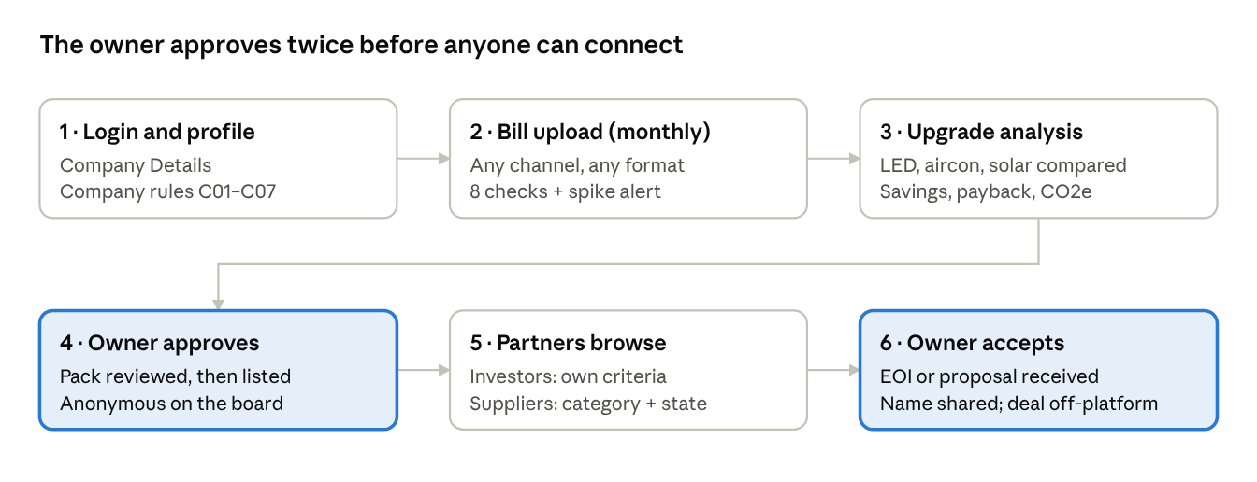
GreenReady journey · 6 stages, 2 owner approvals
Stages 1–3 serve the SME on its own; stages 4–6 open the business to partners, and the owner controls both gates. Every step is written to the activity log.
Inputs (simple to start):
- TNB bill — forwarded on WhatsApp or uploaded as a photo, PDF or screenshot; the only required document
- Company profile — SSM details at login: name, registration no., incorporation date, type, status, nature of business, directors
- Owner form — four questions: lighting type, aircon type, roof access, daytime operation
- Supplier quote (optional) — makes the estimate exact and bank-ready
What each user gets:
User | Main outputs
SME owner | Bill summary, 8/8 checks, spike alert, 6-month trend, side-by-side upgrade options, Preparation Pack, incoming requests to accept or decline
Green investor / bank | Anonymised listings checked against its own criteria, a repayment check on its own terms, a non-binding Expression of Interest after acceptance
Supplier | Listings matching its product and service area, a draft outreach proposal, contact details after acceptance
Core journey (Domain 2 requirement):
Step | What happens
Trigger | Owner forwards the monthly TNB bill
Connected data | AI reads every charge line; company profile and owner form are linked
Decision logic | Fixed rules check the bill (8 checks), flag spikes, and calculate savings, payback and CO2e
Human approval | Staff fix uncertain fields (<85% confidence); the owner approves the listing and each connection
Visible outcome | Preparation Pack, anonymous listing, EOI or proposal — all logged
Boundaries: no credit scores, ratings or loan advice; no upgrade money moves through the platform (GreenReady collects only its own fees); financing and purchases are agreed with licensed banks and registered suppliers. Platforms that fund SMEs directly must be registered with the Securities Commission [25].
Key features (MVP):
# | Feature | What it does | User
F1 | Bill intake | Accepts the TNB bill on WhatsApp or as an uploaded photo, PDF or screenshot; AI reads every charge line with a confidence score | SME owner, staff
F2 | Bill check | 8 fixed checks against the official tariff, a spike alert against the 6-month average, and a usage trend | SME owner
F3 | Upgrade comparison | LED, inverter aircon and solar compared on the same formulas: cost, yearly saving, payback and CO2e | SME owner
F4 | Preparation Pack | A PDF of 6 months of checked bills and upgrade estimates; the owner approves, edits or cancels | SME owner
F5 | Opportunity Board | Anonymous listing; investors see a criteria match and a repayment check on their own terms; suppliers see listings in their category and area | Investor, supplier
F6 | Consent-based connection | Request → owner accepts or declines → details unlock; draft Expression of Interest (investor) or outreach proposal (supplier) | All
F7 | Roles and activity log | Uses Orbyte's login, roles and audit log; every upload, approval and request is recorded | All
Scope:
In scope (prototype) | Out of scope
TNB bills in Peninsular Malaysia (Low Voltage general and domestic tariffs) | Sabah and Sarawak tariffs, smart-meter feeds
Three upgrades: LED, inverter aircon, rooftop solar | Motors, chillers, refrigeration (see Future Enhancement)
SME, investor and supplier dashboards with owner approval | Loan applications, credit scores, ratings or financial advice
Non-binding EOI and indicative outreach proposals | Loans, deposits or upgrade payments moving through the platform
Free credit, pay-per-use and membership billing on synthetic company, bank and supplier data | Real customer data, firm quotations and contracts

3. Innovation: Product Uniqueness
Similar tools exist, so GreenReady does not claim to be the only one. What stands out is the combination: a fair, seller-free comparison of every upgrade, built on a checked bill, with privacy-first matching inside the business hub SMEs already use.
- Fair comparison (most important). LED, inverter aircon and solar use the same formulas, so the SME sees which upgrade really pays back first. Sellers' tools usually push their own product.
- Numbers you can trust. AI only reads the documents. Fixed rules do every savings and carbon calculation and check each bill line against the official tariff, so the same inputs always give the same answer.
- Easy to start. One TNB bill is enough — no ESG report, audited accounts or consultant. A quote is optional.
- Private and fair matching. The SME's name stays hidden until both sides agree to connect. Every investor and supplier gets the same fair chance, and listings are designed around Malaysia's PDPA principles.
- Built into Orbyte. It uses the SME's existing profile, roles and activity log, so there is no new app to learn.
Existing option | What it does | Gap GreenReady fills
Trexon bill analyzer | Reads a TNB bill (also via WhatsApp) and recommends a solar system | A solar seller's funnel; one product; no owner approval or audit log
buySolar | Solar marketplace with installer choice and bank financing | Solar only; no bill checking or other upgrades
UOB U-Energy | One bank's energy-efficiency financing via ESCOs | Single lender; SME still prepares its own evidence
myTNB app | Usage tracking and bill estimates | Monitoring only; no upgrade comparison, investors or suppliers

4. System Architecture and Tech Stack
To be completed by [teammate].

5. Impact and Sustainability Value
GreenReady's main impact is productivity for small firms (SDG 8), with lower energy use and emissions as co-benefits. Over five years the model projects about 169,700 bill checks, 63,700 admin hours saved and 562 completed upgrades.
Impact of one typical upgrade:
Upgrade | kWh saved / year | RM saved / year | CO2e avoided / year | Payback
LED lighting (40 tubes) | 2,696 | 1,366 | 2.0 t | 1.2 years
Inverter aircon (3 units) | 3,151 | 1,597 | 2.3 t | 4.1 years
Rooftop solar (30 kWp) | 39,600 | 20,069 | 29.3 t | 3.0 years
Calculated from published rates: TNB tariff [4], inverter saving 33% [6], LED 18 W vs 36 W (a 2026 Malaysian retrofit measured 44.7% savings) [7], solar yield 1,320 kWh/kWp, between recent Malaysian results of 1,204 and about 1,370 [8]. Savings exclude the AFA fuel surcharge (+3.61 sen/kWh in October 2026) [35], so they are conservative.
Five-year impact (from the financial model):
Measure | 5-year result | Basis
Bill checks automated | 169,728 | Members check every bill; pay-per-use SMEs about 60% of months
Admin hours saved | ~63,700 hours | Target times to be confirmed in our user test
Value created for customers | RM1.69 million | Time saved + 25% of upgrade savings credited to GreenReady
Upgrades completed | 562 | 26% of listings a year [12]
CO2e avoided (credited share) | ~1,180 t | Only 25% of upgrade savings is claimed, to stay conservative
Measured in the demo: time to check one bill (manual vs GreenReady), extraction accuracy on 10 test bills, and the 8 bill checks — our sample TNB bill already passes 8 of 8.

6. Feasibility: Market Value, ROI, Business Model
GreenReady is a small, low-cost module on an existing platform: it needs only 0.2% of the serviceable market in Year 1, breaks even in Year 2, and its main costs are people, not technology.

Market value
Level | Definition | Size
Total market | Micro and small enterprises in Malaysia [1] | 1,081,886 firms
Serviceable market | Manufacturing MSMEs + F&B establishments [1][2] | 195,769 firms
Year-1 pilot | Half of the 600+ SMEs one bank engaged in a quarter [14] | 300 SMEs
Year-5 target | Reached through Orbyte's existing SME users | 10,000 SMEs (5.1% of serviceable)

ROI
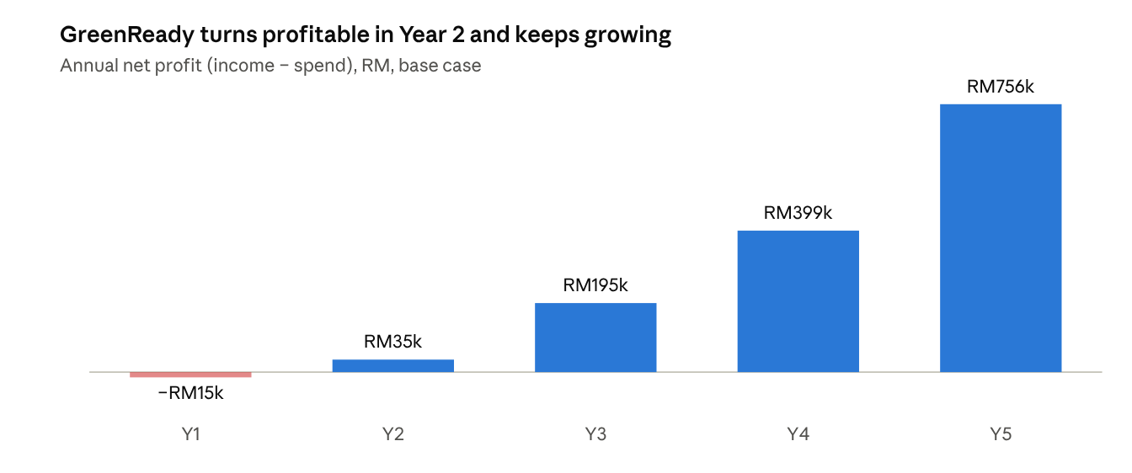
GreenReady financial projection, ROI sheet rows Y1–Y5 (base case)
Year 1 is a small investment year; the cumulative position turns positive in Year 2 and customers gain more than they pay from Year 1.
Year | Income (RM) | Spend (RM) | Cumulative net (RM) | Customer ROI
Y1 | 196,296 | 211,209 | (14,913) | 55%
Y2 | 292,720 | 257,535 | 20,272 | 38%
Y3 | 519,760 | 324,986 | 215,046 | 26%
Y4 | 861,520 | 462,279 | 614,287 | 36%
Y5 | 1,338,000 | 581,756 | 1,370,531 | 39%
- 5-year net profit: RM1.37 million; vendor ROI 74.6%; Year-5 operating margin 56.5%
- NPV: RM441k at a 30% discount rate, the low end of seed-stage practice (30–45%) [17]
- Customer ROI: 36% over 5 years and 55% in Year 1 — every RM1 a customer pays returns about RM1.36 of value, counting only time saved and 25% of upgrade savings

Business model
Revenue stream | Price | Who pays | Share of 5-yr income
Free starting credit | RM10 once (5 analyses) | New SME, one account per SSM number | —
Pay per analysis | RM2 per bill | SME, after the free credit is used | 4%
Membership | RM29 per month | SME; required to contact investors and suppliers | 34%
Supplier connection | RM200 per accepted connection | Supplier, only after the owner accepts | 20%
Investor subscription | RM1,500 per month | Bank or green investor | 28%
Orbyte integration fee | RM70,000 once (Y1) | Orbyte | 2%
Orbyte platform licence | RM70,000 per year | Orbyte | 11%
How it works: every company gets RM10 of free credit once, checked by its SSM number. After that it pays RM2 per bill, or joins as a member for RM29 a month. Membership includes unlimited analyses, the Preparation Pack, the anonymous listing, investor and supplier connections, savings verification after an upgrade and a yearly carbon report. Members keep coming back because each new bill verifies savings and points to the next upgrade.
Why these prices: RM2 is about half the admin time a customer saves per bill (17 minutes at a clerical wage ≈ RM3.90) [11], while AI reading costs GreenReady about 2 sen; RM29 is below entry-level SME cloud accounting (RM35–135) [20]; the supplier fee is under half a commercial solar lead (RM427+) [19]; both Orbyte fees are below Orbyte's RM84k cost to build the module in-house [11]. SMEs now pay 39% of 5-year income and partners 61%.
Unit economics (Year 5): 2,000 members (20% of active SMEs); running cost about RM2.67 per SME a year (AI reading, messaging, hosting); margin about RM1.98 per paid analysis; acquisition cost RM50 per new SME, recovered in about 6 months; payment gateway fees (3% + RM1 per charge) are included in costs [39]. AI reads a document in about 3.5 seconds [32], costing under 2 sen per document [33].
Marketing plan: Y1 pilot with Orbyte's pilot group, 2 founding banks and 5–10 SEDA-registered suppliers; Y2 in-app launch to Orbyte users plus WhatsApp onboarding with RM10 free credit; Y3 bank SME units, supplier associations and SME events; Y4–Y5 other states and new upgrade types. Marketing stays at 13–24% of income.

Key risks and mitigation
Risk | Mitigation
AI misreads a bill (hardest risk) | 8 arithmetic checks against the official tariff; fields under 85% confidence go to staff; manual entry fallback
Partner fees carry 61% of income | SMEs now pay 39% through pay-per-use and membership; 2 founding banks in Y1; stress test shows a RM45/month membership would cover costs alone
Orbyte fees not agreed | Priced below Orbyte's in-house cost; licence negotiable against usage-based credits
Seen as financial advice or unlicensed funding | No scores or ratings; money moves only through licensed banks; Securities Commission rules respected [25]
SME data exposed | Anonymous listings, owner consent for every connection, PDPA-aligned retention and DPO [24]
Fewer SMEs become members than planned | 20% is below the trigger-based benchmark (~25%) [38]; at 15%, vendor break-even moves to Year 3. Test the rate in the pilot; pay-per-use still works without membership

7. Future Enhancement
After the MVP, GreenReady grows in three directions: proving real savings, covering more upgrades and data sources, and deepening the partner side.
- Monthly verified savings. Compare each new bill after an upgrade with the original estimate, so investors and the SME see real results and greenwashing risk falls.
- More upgrade types. Efficient motors and variable speed drives, commercial refrigeration and chillers, heat-pump water heaters and air compressors — common in manufacturing and F&B.
- More ways to send data. Email forwarding, myTNB and smart-meter exports, and Sabah and Sarawak tariffs.
- Supplier bidding. Suppliers submit firm quotes directly on the board, compared side by side on the same formulas.
- Investor tools. Saved criteria with alerts for new matching listings, and a portfolio view of kWh and CO2e saved for green-finance reporting.
- Licensed partner links. Connect to banks' own systems and guarantee schemes so an accepted EOI flows straight into the bank's application, with money still moving only on the partner's side [16].
- ESG questionnaire autofill. Reuse checked energy and carbon data to answer buyers' supplier ESG questionnaires, helping SMEs stay in export supply chains.
- Bahasa Malaysia and Chinese. Summaries and alerts in the owner's preferred language.

8. References
Sources accessed 21–24 October 2026. Problem evidence in Section 1 and competitors in Section 3 are linked in place.
- SME Corp Malaysia (DOSM data) — Profile of MSMEs 2023
- DOSM — Economic Census 2023: Food & Beverage Services
- American Express SME Business Barometer (Jul 2026, UK) — owners spend about 11 hours a week on admin
- Plus Xnergy — July 2025 TNB tariff update (Low Voltage General rates)
- Energy Commission — Grid Emission Factor in Malaysia 2022–2024 (Provisional)
- Salleh et al. (2018), UNITEN — inverter air conditioners use 33% less electricity
- Green Energy and Fuel Research (Jun 2026) — Malaysian LED retrofit cut energy use 44.7%
- EPJ Web of Conferences (2026) — 23.4 kWp rooftop PV in Kuala Lumpur, ≈1,204 kWh/kWp/year
- Trexon — Solar panel price Malaysia 2026
- Trexon — SEDA RPVSP checks and quotation checklist
- RinggitPlus — DOSM Salaries & Wages Survey 2025
- Alliance Bank — ESG 2.0 Report (Jan 2025)
- Business Today — UOB Business Outlook Study 2026
- RHB Bank — LCTF portfolio guarantee; 600+ SMEs engaged
- Bank Negara Malaysia — Low Carbon Transition Facility FAQ
- Bank Negara Malaysia — Additional allocation and shift to guarantee-based SME support (Jan 2026)
- OpenForest — startup discount rates by stage
- Gripped — B2B SaaS CAC benchmarks 2026
- WhySolar — solar lead costs
- Bukku — SME cloud accounting pricing
- Wikipedia — List of banks in Malaysia
- CGC — SME definition table
- 3E Accounting — SSM e-Info company profiles
- DFDL — PDPA (Amendment) Act 2024 obligations
- Securities Commission — List of Registered Recognized Market Operators (P2P and ECF platforms)
- NST — Energy Efficiency Incentive limits (Jun 2025)
- SoyaCincau — 800 kWh domestic exemption, Sep–Dec 2026
- Hong Leong Bank — SME Solar Financing
- TNB — myTNB app and monthly billing (The Star, May 2025)
- Meta — WhatsApp Business Platform pricing
- MakerKit — Supabase pricing 2026
- arXiv 2609.15706 — vision-language models for document extraction
- RunPod — Serverless GPU pricing
- DOSM — MSMEs Performance 2025 (released 30 Jul 2026): 39.7% of GDP, 8.09 million jobs
- Trexon — TNB tariff 2026: RP4 base rates fixed to 2027; AFA +3.61 sen/kWh in Oct 2026
- Springer, J. Renewable Energy & Environment (2023) — Selangor PV ≈1,370 kWh/kWp/year
- Lawrence Berkeley National Laboratory (Jan 2025) — Malaysia room air-conditioner market study
- Userpilot, citing ChartMogul / ProductLed SaaS Conversion Report (Jan 2026) — freemium-to-paid benchmarks
- Airwallex (Jun 2026) — Malaysia payment gateway fees

